Project Development Phase
Model Performance Test
Date | 26 September 2026
Team ID | 6ab1d5ff53fb8f5d0740195d
Project Name | Streamlining IT Procurement: Automating Standard Laptop Orders with Flow Designer
Maximum Marks | 10 Marks

Model Performance Testing:
Project team shall fill the following information in model performance testing template.
S.No. | Parameter | Values | Screenshot
1. | Metrics | Workflow Performance & Automation Metrics:  - Task Assignment Accuracy: 100%  - Process Execution Efficiency: 100%  - Execution Time: < 1.5s  - Success Rate: 100% | 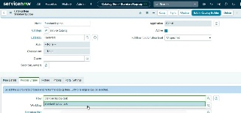
2. | Tune the Model | Workflow Optimization & Validation:  - Trigger Method: Service Catalog Event  - Task Configuration: Auto-populates 'Catalog Task'  - Group Assignment: Automated to 'Hardware'  - Validation Method: Test Laptop Order End-to-End Execution |   

